**BS-3304L Numerical Analysis Lab**

**Secant Method**

The **secant method** is a root-finding procedure in numerical analysis that uses a series of roots of secant lines to better approximate a root of a function. For the function, $f(x)$, shown in Figure 1, the definite integral within the limits $a$ and $b$ is,

The tangent line to the curve of y = f(x) with the point of tangency (x0, f(x0) was used in Newton’s approach. The graph of the tangent line about x = α is essentially the same as the graph of y = f(x) when x0 ≈ α. The root of the tangent line was used to approximate α.

Consider employing an approximating line based on ‘interpolation’. Consider we have two root estimations of root α, say, x0 and x1. Then, the linear function is:

q(x) = a0 + a1x

using q(x0) = f(x0), q(x1) = f(x1).

This line is also known as a secant line. Its formula is as follows:

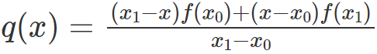

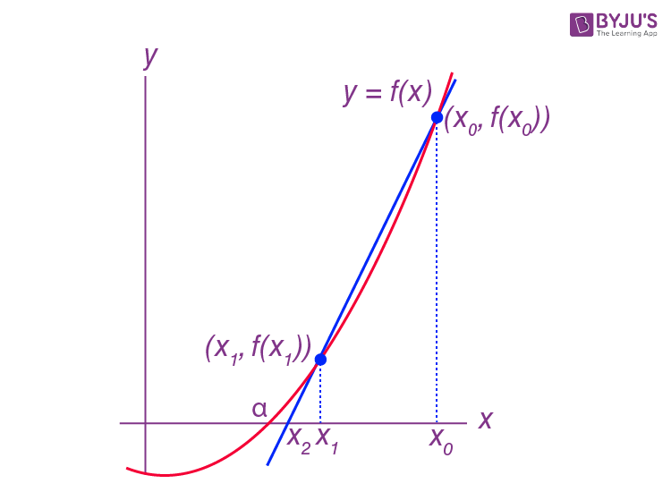

Figure 1

**Task 1**

Develop a MATLAB function for the Secant method for the following function:

$$f\left(x\right)=xsinx$$

The function should accept the function Limits (x1 and x0)

**Code:**

|  |
| --- |
| clc, clear  %% Defining Function and Variables    f = @(x) x*sin(x)    x0 = 1;  x1 = 3;  xi = x0;  xf = x1;    n = 0;  yi = 1;  yf = 1;    %% Program    fprintf("\n")  fprintf("Iteration Root f1 f2\n")    while yi ~= 0 && yf ~= 0  if yi ~= 0 && yf ~= 0  yi = f(xi);  yf = f(xf);    x2 = xf - (((xf-xi)*(yf))/(yf-yi));    xi = xf;  xf = x2;    n = n + 1;  yi = round(yi,4); %Rounding off correct to 4 decimal points  yf = round(yf,4); %Rounding off correct to 4 decimal points    fprintf("%.1f %.4f %.4f %.4f\n", n, x2, yi, yf)    else  break  end  end |

**Command Window:**

